Cooperative Learning and Classroom Management Issues Related to CBL Units

Speaker: Tim Dugan, CEEMS Resource Teacher Mentor and Stephanie Romer, CEEMS Teacher
Date: Thursday, June 30, 2016
Time: 9-11 AM
Venue: University of Cincinnati, Zimmer Hall, room 414

Prepared by:
Samy Lafin, Scott High School, Taylor Mill, KY
RET Participants for Project #3: “Enhancing Decision Making Emulating Human Reasoning”

This session was given by Tim Dugan, CEEMS Resource Teacher Mentor and Stephanie Romer, CEEMS Teacher on Thursday, June 30, 2016 from 9-11 AM at the University of Cincinnati in Zimmer Hall, room 414.

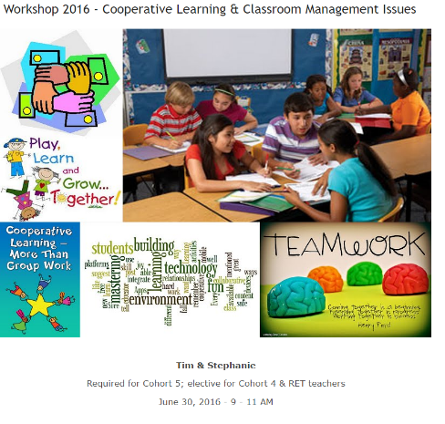
Debbie Liberi opened the session by presenting Tim Dugan and Stephanie Romer, as seen in Figure 1. Mr. Dugan is a current University of Cincinnati resource teacher with CEEMS, was an adjunct with college of education at the university, and is a consultant with a local architectural firm that focuses on school improvement. He was a social studies teacher at Princeton High School for 28 years and also spent five years in the administration in the same district. Mr. Dugan was the Ohio Teacher of the Year in social studies, and has received many awards for his use of technology in the classroom. Also, Mr. Dugan taught educational technology for teachers and classroom management as an adjunct professor for the University of Cincinnati. Mr. Dugan has his Bachelor’s of Science from Miami University, and his Master’s Degree in Administration from Xavier University. Ms. Romer teaches science at Winton Woods Middle School. She has her Bachelor’s Degree from Miami University, and has taught for the past three years. Mr. Dugan then welcomed the group and introduced the workshop.
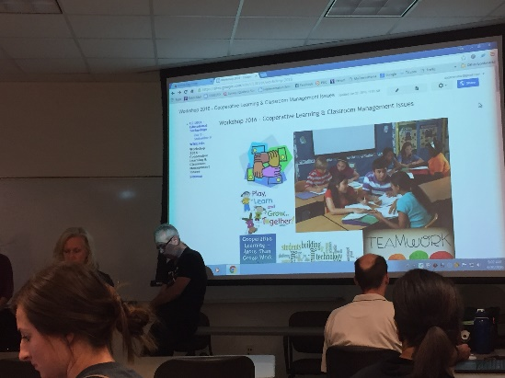
Figure 1: Debbie Liberi introducing presenters Figure 2: Initial website for the seminar

The goals for the workshop was to look at how to use collaboration in the classroom, including developing collaboration into lessons teachers already use, and foster a community of collaboration between the students using technology and classroom management. The goals and agenda for the website could be seen on the website in Figure 2.

The first activity was to have teachers look over a Collaborative Learning website from Cornell University. Teachers scanned the website to search for ideas they already understand or use in their classrooms. Some ideas shared with the group were to give enough time to work on the activity, use your time wisely to talk to the students and debrief the students, the student teams work on a common goal, and examples of different types of collaborative learning and evaluation. Mr. Dugan presented the acronym CIA, which stood for curriculum, instruction, and assessment. Mr. Dugan then asked teachers to discuss a time where they have tried collaborative learning in the classroom. Some teachers talked about the labs they do in their classroom, collaborative activities, and what worked and didn’t work with those activities.

The presenters then showed a short video from Edutopia (http://www.edutopia.org/stw-collaborative-learning) on utilizing collaboration in classrooms. The example in the video was a college prep school that actively uses collaboration in their classrooms. Some of the key ideas presented in the video were what a “good” collaborative group looks like and the atmosphere and expectations in the classroom. The video also discussed roles for students during a large group discussion including a scribe, a student who creates a visual map of how the discussion is going, and a moderator who made sure all voices were heard and the discussion moved at a good pace. Ms. Romer then asked all the groups to discuss the benefits they saw in the video. A discussion began about how the environment seen in the video is optimal, very unlike the public school classrooms that many of the teachers attending the seminar taught in. Mr. Dugan defined an idea of how a teacher could self-assess themselves and how they teach in order to make sure a teacher gave the appropriate amount of attention to all students in the classroom. He also discussed why movement by a teacher throughout the room is beneficial to all the students, as seen in figure 4.

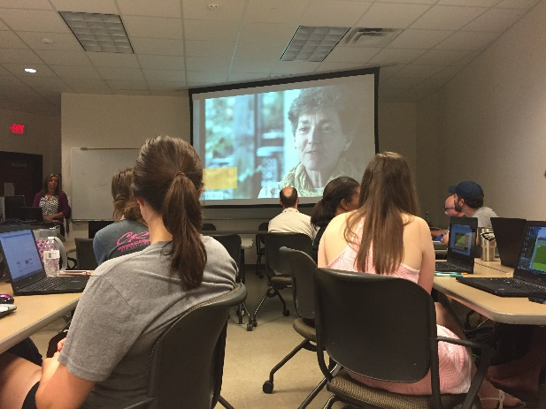
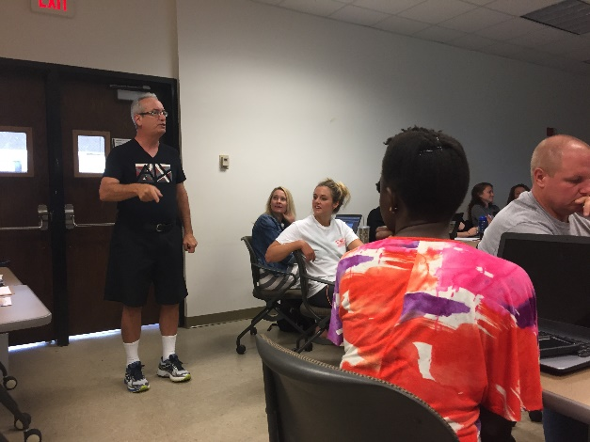

Figure 3. Edutopia Video Figure 4. Mr. Dugan discussing teacher movement

After the video, the presenters had the teachers in the seminar take a brief quiz from Edutopia on multiple intelligences. Ms. Romer shared that she does this same activity with her students at the beginning of every year. Once all the teachers had taken the quiz, Ms. Romer shared how she uses this in her classroom. After the quiz, the teacher groups worked on a challenge to build the tallest paper tower, with three sheets of paper and tape. Ms. Romer discussed how she uses this activity to teach collaboration and team work in her classroom.

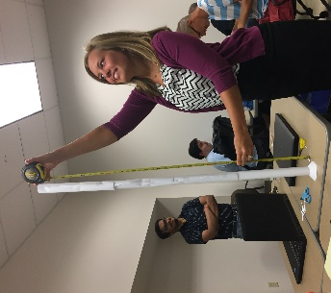
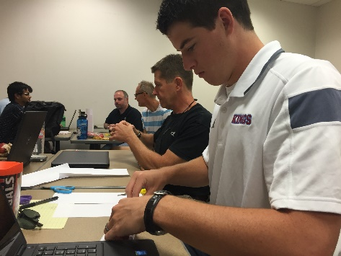
Figure 5. Building the paper tower Figure 6. Measuring the towers

After the collaboration activity, Mr. Dugan introduced the idea of a sociogram, where you create a picture of who students want to work with. The picture is then used to determine good grouping for the students. Ms. Romer also discussed doing grouping randomly or not sharing your reasoning behind groups. The idea of roles in a group was discussed as well as staying strict on time limits. Mr. Dugan then presented the graphic in Figure 7 and had the teachers discuss how this picture played a part in their classrooms. He shared a personal experience, with the overall moral being that our job isn’t to focus on what did a teacher teach, rather what did a student learn. Mr. Dugan also shared a graphic that discussed how different factors affect student learning.

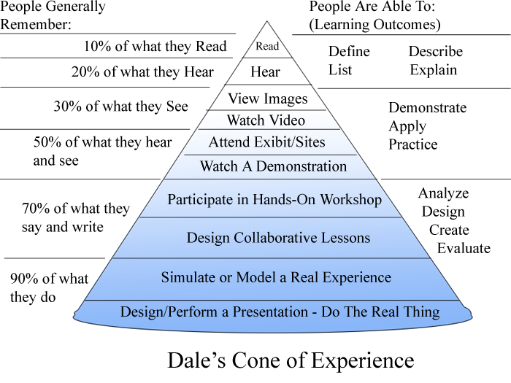
Figure 7. Dale’s Cone of Experience

Overall, this was a very effective workshop. Since all the teachers who attended the seminar are learning how to use challenge-based learning and engineering in their classrooms, it is important for them to understand effective methods of implementing team work and collaboration in the classrooms. An interesting point from the seminar was that Mr. Dugan and Ms. Romer never met in person before the seminar, but the entire workshop was created through technology, including Skype and a Wiki page. This shows how effective technology can be, when used appropriately.

